[Password Safety Hub] Site Plan

[Brandon Gomez]

WDD 130

Overview

Purpose
[Help inform people of password safety techniques]

Audience
[people who keep getting hacked]

Branding

Website Logo
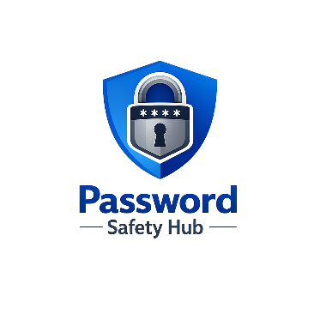

Style Guide

Color Palette
Primary | Secondary | Accent 1 | Accent 2
#1D4ED8 | #0F172A | #60A5FA | #E5E7EB

Typography

Heading Font: [Cambria]

Paragraph Font: [Calibri Light]

Navigation
Home Page2 Page3

Content

Content
Home Page
Introduction
Passwords protect many of the most important parts of our digital lives, including email, banking, social media, and school accounts. Many people still use weak passwords or reuse the same password across multiple websites. This website will help people learn how to create stronger passwords and manage them safely so their accounts are better protected.
Why Password Security Matters
If someone gains access to your password, they may be able to access personal information, send messages from your account, or steal sensitive data. Learning good password habits can greatly reduce the risk of being hacked.
Common Password Mistakes
Many people use passwords that are too simple, such as "123456", "password", or their birthday. Another common mistake is reusing the same password on many websites. If one site gets hacked, attackers may try that same password on other accounts.
Images
- Lock or cybersecurity image
- Login screen or password graphic

Page 2 – Creating Strong Passwords
What Makes a Strong Password
A strong password should be long, unique, and difficult to guess. It should include a mix of letters, numbers, and symbols. Avoid using names, birthdays, or common words.
Using Passphrases
A passphrase is a longer password made from several words. For example, a phrase like:
BlueCoffeeRocket!42
is much stronger than a short password like "abc123".
Passphrases are easier to remember but harder for attackers to guess.
Password Tips
- Use at least 12–16 characters
- Avoid common words or personal information
- Do not reuse passwords on multiple websites
Images
- Password strength graphic
- Security shield or lock icon

Page 3 – Password Managers
What is a Password Manager
A password manager is a tool that stores all of your passwords in one secure location. Instead of remembering dozens of passwords, you only need to remember one master password.
Benefits of Password Managers
Password managers help generate strong passwords and automatically fill them in when logging into websites. This makes it easier to use unique passwords for every account.
Extra Security Tips
Using two-factor authentication (2FA) adds an extra layer of protection to your accounts. Even if someone steals your password, they will still need a second verification code to log in.
Images
- Smartphone authentication image
- Password vault or lock graphic

Wireframes

Home
